Optimized Strength Training
Fitness Schedule

Overall Rules:
- Bigger muscles before smaller muscles
  - Chest -> Shoulders -> Biceps/Triceps
  - Quads/Hamstrings -> Calves/Abs
- Inhale on muscle relaxation, exhale during exertion
- Count each rep out loud

Week 1  Day | Muscle Group
Sunday | Break
Monday | Core Variation 1
Tuesday | Upper Day 1 Variation 1 (back -> arms)
Wednesday | Break
Thursday | Legs Variation 1
Friday | Upper Day 2 Variation 1 (back -> arms)
Saturday | Break

Week 2  Day | Muscle Group
Sunday | Break
Monday | Core Variation 2
Tuesday | Upper Day 2 Variation 1 (back -> arms)
Wednesday | Break
Thursday | Legs Variation 2
Friday | Upper Day 2 Variation 2 (back -> arms)
Saturday | Break

Meditation:
- optimal in the morning (before eating)
- alternatively good 1.5 hours after waking up to use the first 1.5 hours to get the most important task of the day done.

Sequence: Warmup / posture -> workout
walking (8pm)

Neck exercises:

Posture exercises – Upper Body

Warmup | Targets | Technique
Over and Backs | Upper Trapezius  Pectorials  Anteroir Deltoids | - Wide overhand grip holding a resistance band (start wider and slowly narrow down). Around 90 degrees at first.  - Rotate arms behind head as far back as possible without bending at the elbows and straining your neck forward.
Cobra Pose | Entire Body | - Feet about hip width apart, toes facing down to flatten foot, hands directly under shoulders.  - Contract quads so that the knees are off the ground.  - Bring shoulder blades down and back.  - Think about bringing your upper body forward and upwards. Remember your arms are only for stability.  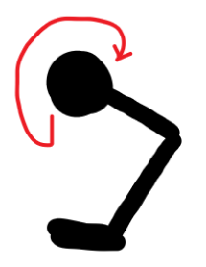
Stand and Reach | Tightened Hip Flexors | - Hold one hand at hip  - Extend up and back behind your body at a diagonal. Stretch the side that feels tighter longer
Wall Slides with Chin Nods | Lower Trapezius  Neck Flexors | - Upper and lower back against a wall  - Feet slightly in front and hip width apart  - Raise arms and extend  - Simultaneously perform a chin nod by pushing chin in to your neck  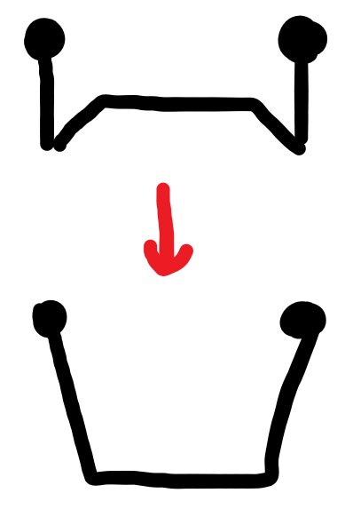

Posture exercises – Lower Body
Warmup | Targets | Technique
Quadruped Thoracic Rotations | midback mobility hunched over posture | - Get on all fours, knees slightly further out than hips. Sit hips back towards heels. Place one hand extended out in front and the other behind your neck  - Bring elbow down towards floor. While following elbow with your eyes, rotate elbow up towards ceiling as far as you can, hold top position briefly, then go back down.  - Do other side.  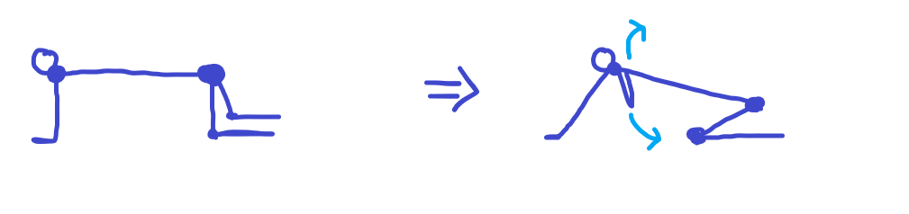
Kneeling Hip Flexor Stretch | hip flexors | - Kneel on the floor and contract glutes and abs to straighten spine.  - Lean forward until you feel a deep stretch in the front hip of your back leg.  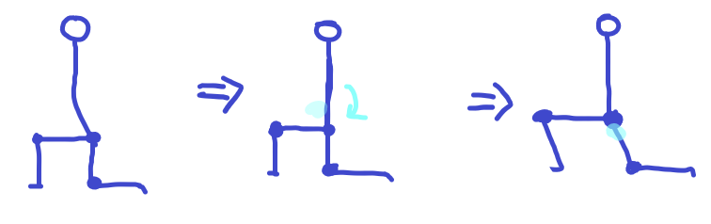
Seated Pigeon Pose | Tightened Hip Flexors | - Sit on a chair with glutes resting on chair. Put opposite legs’ ankle right above the knee.  - Lean forward and stretch for around 10 seconds.  - Do other leg  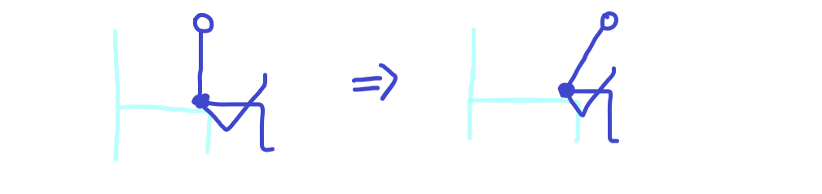
Glute Bridges | Glutes | - Feet hip width apart, pointed slightly outwards, flat on floor.  - While keeping back straight, use glutes to thrust your hips in to the air. Hold top position while contracting glures, and hold for 2-3 seconds.  3 sets, 10-15 reps  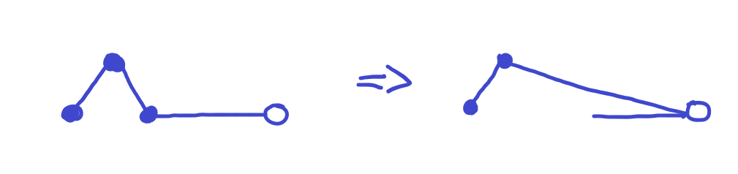

CORE / Lower back
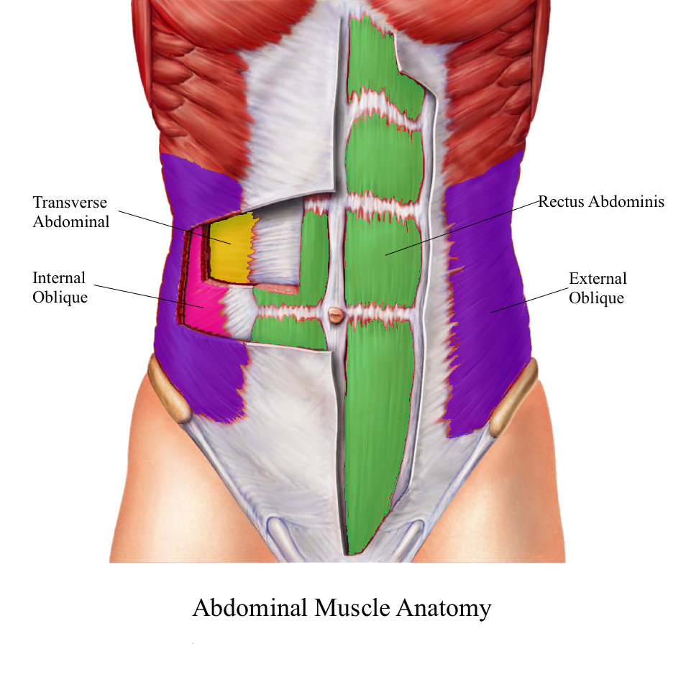

Core Muscles | Function
External Oblique | responsible for the twisting of the trunk
Internal Oblique | flex the trunk compress its contents (bilaterally) and rotate it to the same side (unilaterally)
Rectus Abdominis | flex the spinal column or trunk of the body
Transversus Abdominis | involved in moving the trunk, but also stabilizes the vertebral column, creates tension of the anterior body wall and increases the intraabdominal pressure upon contraction

Exercise | Primary Muscles | Secondary Muscles | Technique
Elbow Plank | Rectus Abdominis  Obliques | 0 | With a completely straight back and legs, rest on 90 degree angled arms with clenched fists and hold posture using core muscles
Side Plank | Obliques  Rectus Abdominis  Transverse Abdominis  Gluteus Minimus  Gluteus Medius  Adductor | Gluteus Maximus  Quadriceps  Hamstrings | With your elbow in a 90 degree position, put your legs together and rest on the side of one foot and hold while making sure your body is straight
Straight Leg Raises | Iliopsoas/Hip Flexor (part of the Quadriceps)  Rectus Abdominis  Obliques
Plank Roll | Core muscles  Obliques |  | With your buttocks in the air at around a 45 degree angle, rotate your hips to the left and right in alternate motions
Bird-Dog Exercise | 0 | Abdominals, lower back, gluteal muscles, thigh muscles | Step-by-Step Instructions  Find a soft surface to kneel on and enough space to extend both an arm and a leg at the same time. An exercise mat is a good choice of surface.  - Kneel with knees hip-width apart and hands firmly on the ground about shoulder-width apart. Brace the abdominals.  - Practice lifting one hand and the opposite knee just an inch or two off the floor while balancing on the other hand and knee and keeping your weight centered.  - When you feel steady and ready to move on to full range of motion, point the arm out straight in front and extend the opposite leg behind you. You should form one straight line from your hand to your foot, keeping hips squared to the ground. If your low back begins to sag, raise your leg only as high as you can while keeping your back straight.  - Hold for a few seconds, then return your hands and knees.  - Switch to the other side.  - Keep the abs engaged throughout the entire exercise, and work to minimize any extra motion in your hips during the weight shift  Aim to complete 5 strong reps on each side, 10 reps total. Add additional sets of 10 exercises for a maximum of three sets of 10. As a variation, you can do a set of 10 bird-dogs on one side, then switch to the other side.  Common Mistakes  Watch your form. If your chest sags down, your shoulders will be too close to your ears.  To test how stable you are and whether you have proper form, have someone place a plastic cup on your lower back.1﻿ If it falls off, you need to continue to work on extending one leg or one arm at a time.
Plank Crunch |  |  | Squeeze quads and butt cheeks, pull belly button up; crunch in (move lower back upwards) extend back towards the ground
Heel Touches (Toe Taps) | Obliques  Upper Rectus Abdominis

UPPER Body (Arms, back, shoulders)
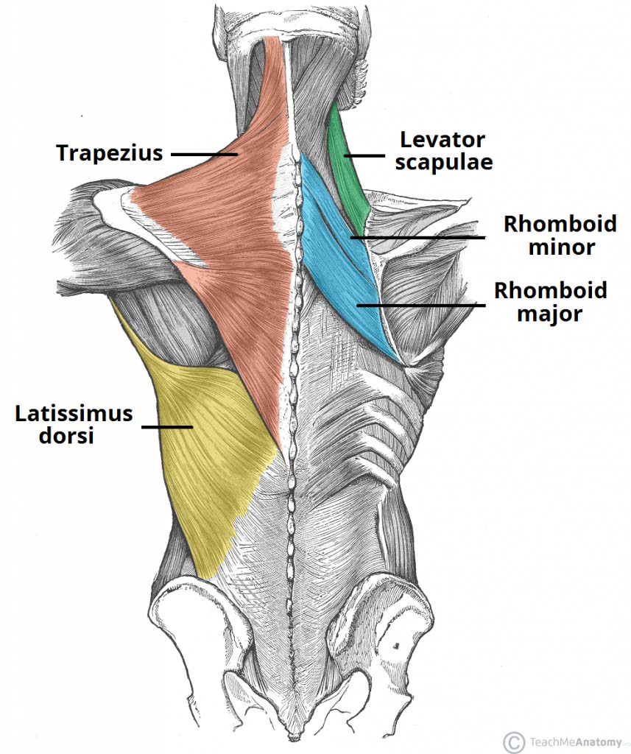
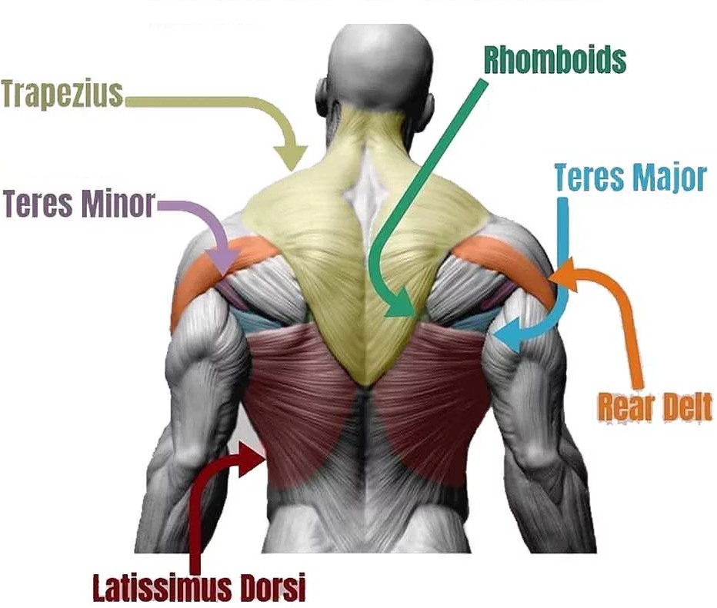

Back + Shoulders Muscles | Function
Lower Trapezius | Depresses the scapulae.
Upper Trapezius | Elevates the scapulae
Anterior Deltoid | assist the pectoralis major to flex the shoulder
Posterior Deltoid | assist the latissimus dorsi to extend the shoulder
Intermediate Deltoid | perform basic shoulder abduction when the shoulder is internally rotated, and perform shoulder transverse abduction when the shoulder is externally rotated
Teres Major | Assists in the extension and medial rotation of the humerus.
Teres Minor | Modulates the action of the deltoid, preventing the humeral head from sliding upward as the arm is abducted. It also functions to rotate the humerus laterally.
Pectoralis Major | flexion, adduction, and internal rotation of the humerus
Neck Flexors | perform simple movements such as nodding and turning the head
Erector Spinae | group of muscles and tendons that straighten and rotate the back
Rotator Cuff | a group of muscles and their tendons that act to stabilize the shoulder and allow for its extensive range of motion.
Latissimus Dorsi | Responsible for extension, adduction, transverse extension also known as horizontal abduction, flexion from an extended position, and (medial) internal rotation of the shoulder joint. It also has a synergistic role in extension and lateral flexion of the lumbar spine.
Rhomboids

Arm Muscles | Function
Biceps | two-headed muscle whose function is at the elbow where it flexes the forearm and supinates the forearm
Brachialis | flexes the elbow joint
Triceps | responsible for extension of the elbow joint (straightening of the arm).
Forearm | many muscles, including the flexors and extensors of the digits, a flexor of the elbow (brachioradialis), and pronators and supinators that turn the hand to face down or upwards, respectively.
Brachioradialis | flexes the forearm at the elbow

Day 1 Variation
Upper Body Vertical Push (shoulder press)
Upper Body Vertical Pull (pull ups, assisted??)
Upper Body Horizontal Push Exercise (floor press)
Upper Body Horizontal Pull Exercises (bent over rows)
Triceps (triceps extension seated)
Biceps (hammer curls, bicep curls)

Day 2 Variation
Upper Body Horizontal Push Exercise (push up)
Upper Body Horizontal Pull Exercises (one arm dumbbell row)
Upper Body Vertical Push (shoulder press)
Upper Body Vertical Pull (pull ups, assisted??)
Triceps (triceps extension (standing))
Biceps (hammer curls, bicep curls/supinating (alternate))

Exercise | Primary Muscles | Secondary Muscles
Bicep Curls | Biceps | Brachioradialis  Brachialis | Back foot on toe (will cause postural instability that forces you in to good posture), retract shoulders and elbows by your side (imagine a pen going in through your elbow in to the side of your hip and out the other end) – make sure you are moving your elbows on that axis and that your elbows never leave this position. You are ONLY moving your forearm up and down.
Supinating Bicep Curl | biceps, brachialis, brachioradialis | pronator teres, extensor carpi radialis longus, flexor digitorum superficialis,  flexor carpi radialis
Shoulder Scaption Raise (not a lot of weight, isolation exercise) | serratus anterior (upper side back), deltoids and supraspinatus (shoulder blades) |  | Feet shoulder width apart, with thumbs pointed up. Raise dumbells up in a wide V. Squeeze shoulder blades together and hold for a single second. Lower and repeat.
Side Lateral Raise
Shoulder/Overhead Press | Anteroid Deltoid  Intermediate Deltoid | Upper Trapezius  Rectus Abdominis | Arms to the side with the elbows pointed downwards and the dumbbells parallel to the floor, thumbs pointed inwards. Push straight up. On the way down, make sure elbows are SLIGHTLY in front of your body to not put the pressure on your back.
One arm dumbbell row | Main muscles: latissimus dorsi, teres major and minor, deltoid (rear) | Secondary muscles: rhomboids, biceps, brachialis, brachioradialis, trapezius, erector spinae | STARTING POSITION (EXERCISE SETUP): Set a dumbbell on the floor near one end of a bench. Position yourself so that one foot is firmly on the floor next to a flat bench, and the opposite leg’s knee is on the centerline of a bench. Grasp a dumbbell with the other hand (on the side where your foot is on the floor) using neutral grip. Your knee should be directly below your hip and your hand directly below your shoulder. Your spine should be horizontal and parallel to the benchOne Arm Dumbbell Row Exercise  MOVEMENT (ACTION): Pull the dumbbell up and in toward your torso (to your lower rib cage). Your elbow should be pointing up at the top of the movement. Retract your working scapula at the top. Reverse the movement, but do not take tension off the musculature or let the dumbbell touch the ground. Keep your torso still during the exercise, and keep the extraneous movement to a minimum. Perform all the reps for one side, then all the reps for the opposite side. Work your weaker side first.  Additional Tips & Key Points  - Keep your back straight and your eyes facing down.  - Straighten your back and set your torso perpendicular to the bench and the floor, or just above perpendicular (your shoulders can be slightly higher than your hips).  - Pull the dumbbell up and in toward your torso, raising it as high toward your chest (just below the armpit) as possible. Your working elbow should point up toward the ceiling as you lift. Focus on leading with your elbow, initially pulling it straight up toward the ceiling, then angling it back slightly.  - Your shoulder and elbow joints should be your only moving parts; your lower body and trunk should remain still.  - Concentrate on using your middle and upper back muscles to pull the dumbbell up and back toward your hip. Make sure you row the dumbbell to the side of your ribcage – do not pull it up to your shoulder.  - Avoid allowing your working elbow to migrate away from the side of your torso during any part of the movement. Also, avoid any spinal movement or hip rotation. Do not jerk the weight up or rotate the body during the lift. If this happens, you are lifting too much weight  - Pulling the dumbbell toward the chest works the upper latissimus and lower trapezius. Raising the dumbbell through a lower trajectory toward the abdomen targets the lower lats.  - Inhale just before you bring the dumbbell up, hold your breath at the top of the movement and exhale as you lower the weight.  - When you complete the set, set the dumbbell on the floor and then stand on the other side of the bench.  Lifting your head or turning your neck to see the weight can strain your neck muscles. Instead, look down at the bench—or the floor in front of you—as you row.
Hammer Curls | Brachioradialis  Brachialis | Biceps | Proper Form & Technique  STARTING POSITION (SETUP): Stand erect while holding a pair of dumbbells at your sides (against your outer thighs), with your palms facing in (your thumbs pointing forwards). Pull your shoulders back, keep your chest high, and your spine neutral. You should be facing forward with your head up.  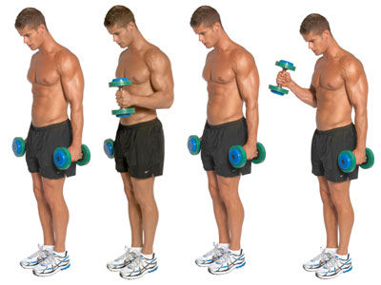  Hammer Dumbbell Curl Exercise  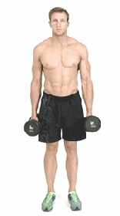  alternating standing hammer dumbbell curls  MOVEMENT (ACTION): Curl the dumbbell in an upwards arc towards your shoulder until your forearm touches your biceps, without rotating your wrist. Keep your abs tense and your chest high throughout the whole movement. Pause for a second at the top of the movement before returning the weight to the start position under control. Work your arms alternately. Always keep your elbows in at your sides.  Elbows slightly in front of the hips, dumbbells parallel to each other, bring up dumbbells just pass the elbow being 90 degrees. Make sure to not straighten the elbows and keep them slightly bent at the neutral position.
Triceps Extension |  |  | Stand with your feet shoulder-width apart.  - Keep a slight bend in your knees.  - Hold a weight with both hands over your head.  - Lower it behind your head, keeping your elbows close to your ears.  - Press it back up.  - Repeat for 45 seconds.  Make a triangle with your hands so that the palms point upwards. Elbows stay glues to ears, point forward, do not move their position. You are using the elbow to bend and bring the dumbbell up and down. Do not let the dumbbell pull you backwards. Elbows almost reach a 90 degree angle.
Bent over rows | Middle/Lower Trapezius  Teres Major  Teres Minor  Rhomboids | Posterior Deltoid  Latissimus Dorse  Brachialis  Pectoralis Major | Overhand grip with hands just outside thighs, feet under hips, shoulders back, chest upwards. Push butt outwards making sure neck is inline with the spine, eyes a meter in front on the floor (will give you the right angle). Pull dumbbells up in to the belly button, keeping elbows tucked in, and squeeze shoulder blades. Elbows should crease at ~around a 90 degree angle.

Workout LEGS
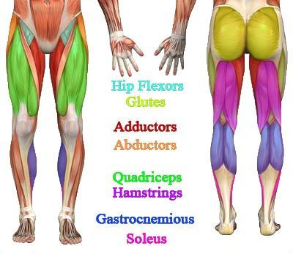
Starting with compound movements, such as squats, lunges, and deadlifts to target your entire lower-body musculature, then incorporating hip thrusts or bridges to isolate your glutes and build power as you learn to effectively extend your hips.

Leg  Muscles | Function
Gluteus Maximus | External rotation and extension of the hip joint, supports the extended knee through the iliotibial tract, chief antigravity muscle in sitting and abduction of the hip
Gluteus Medius | abduction of the hip; preventing adduction of the hip. Medial/internal rotation and flexion of the hip (anterior fibers). Extension and Lateral/external rotation of the hip (posterior fibers)
Gluteus Minimus | Works in concert with gluteus medius: abduction of the hip; preventing adduction of the hip. Medial rotation of thigh.
Gastrocnemious | primarily involved in running, jumping and other "fast" movements of leg, and to a lesser degree in walking and standing
Tibialis Anterior | dorsiflex and invert the foot
Hamstrings | flex the knee joint and extend the thigh to the backside of the body
Quadriceps | All four quadriceps are powerful extensors of the knee joint
Adductors | group of muscles mostly used for bringing the thighs together
Abductors
Tensor fasciae latae | assists in keeping the balance of the pelvis while standing, walking, or running.
Sartorius | Flexion, abduction, and lateral rotation of the hip, flexion of the knee.
Soleus | plantarflexion of the foot (that is, they increase the angle between the foot and the leg)

Warmup | Primary Muscles | Secondary Muscles
Standing Quad Stretch

Clamshell | Gluteus Medius  Gluteus Maximus | Lie on your right side with your feet and hips stacked, your knees bent 90 degrees, and your head resting on your right arm.  - Draw your knees in toward your body until your feet are in line with your butt. Place your left hand on your left hip to ensure it doesn’t tilt backward. This is your starting position.  - Keeping your abs engaged and your feet together, raise your left knee as far as you can without rotating your hip or lifting your right knee off the floor.  - Hold for 1 second, squeezing your glutes at the top of the move, before slowly lowering your left knee to the starting position.  - Continue for a total of 20 reps, then repeat on the other side.

Exercise | Primary Muscles | Secondary Muscles
Squats
Step Ups | Quadriceps  Gluteux Maximus | Adductors (leading leg)  Calves (following leg)  To start, place your entire right foot onto the bench or chair. Press through your right heel as you step onto the bench, bringing your left foot to meet your left so you are standing on the bench.  - Return to the starting position by stepping down with the right foot, then the left so both feet are on the floor.  - Complete 15 steps leading with the left foot, then repeat another 15 steps leading with your left foot. Do three sets.
Hip Thrust
Calf Raises

Resources

https://www.fitmole.org/upper-lower-split
https://darebee.com/
https://www.muscleandstrength.com/articles/overtraining-why-less-is-more.html
https://www.weight-lifting-complete.com/major-muscle-groups/

